Chengdu Gold Armor Technology Inc.
Live 800 15.0 is described in this text.
Catalogue
One. Login - 5 -
1.1 Login Interface - 5 -
1.2 System Main Interface - 6 -
Two. Chat Management - 7 -
2.1 Toolbar - 7 -
2.2 Visitor List - 8 -
2.3 Chat Interface - 9 -
2.4 IM Chat - 9 -
2.5 Operator Commonly Used Functions - 10 -
You can click on the arrow to maximize or minimize extended function. - 10 -
Three.Teamwork - 12 -
3.1 Co-work - 12 -
3.2 Operators - 12 -
3.3 Group - 13 -
3.4 ACD - 13 -
3.5 ID Activity - 13 -
3.6 Bulletin - 14 -
Four. Archives - 14 -
4.1 Chat History - 14 -
4.2 Offline Msg - 14 -
Five CRM System - 15 -
5.1 Follow up - 15 -
5.2 Client Query - 15 -
5.3 Add Client - 15 -
5.4 Category - 15 -
5.7 Area - 16 -
5.8operator analysis - 17 -
5.9 Msg Query - 17 -
5.10 Customize - 17 -
Six. Analytics - 19 -
6.1 Web Overview - 20 -
6.2 Traffic Source - 21 -
6.3 Visitor Loyalty - 22 -
6.4 Page content - 23 -
6.6 Visitor Info - 25 -
6.7 Archives - 25 -
6.8 Operators - 26 -
Seven. Configuration - 26 -
7.1 Page Code - 26 -
7.2 Invitation Window - 27 -
7.3 Chat Window - 27 -
7.4 Offline Msg - 27 -
7.5 Visitor Info - 28 -
7.6 Service Area - 30 -
7.7 Login IP - 30 -
Eight. Enhancement - 31 -
8.1 Robot - 31 -
8.2IM Chat - 31 -
8.3 Website Monitor - 31 -
Nine. User Center - 31 -
9.1 Billing - 31 -
9.2 Company Info - 32 -
9.3 My Profile - 33 -
9.4 Feedback - 34 -
Ten. System Display and Set Instruction - 34 -
10.1 Display - 34 -
10.2 Setting - 35 -
10.3 Main Menu - 36 -

One. Login

1.1 Login Interface
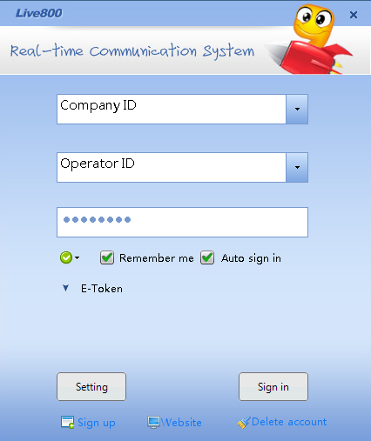
Company ID
Company ID, generated automatically by the system after registration of Live800 service, is unique.
Operator ID
With a default administrator right, the initial operator ID is appointed by the user at the registration of Live 800 service. The administrator can operate the configuration and management of Live 800 service, and establish a series of customer service ID and set the purview role.
Password
Password is the one you have registered, you can select Remember me for convenient use.
Website Login
You can click Website to login, by which you could test software and manage company information.

1.2 System Main Interface
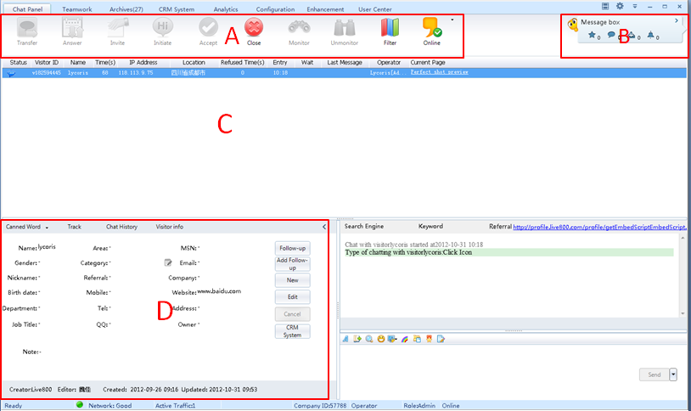
System is mainly divided into Operation Toolbar（A）;Message Center（B）;Chat Interface（C）;Canned Words and Canned Links and so on(D).
Icon of lower right corner is the status of Live800 under operation:
Operator is offline
Operator is online
Operator is busy
Operator is away
Operator is invisible(Only for admin)
Operator is in need, such as chat request from visitor, dial back is on, new message, chat transferring from other operators and so on.

Two. Chat Management

2.1 Toolbar
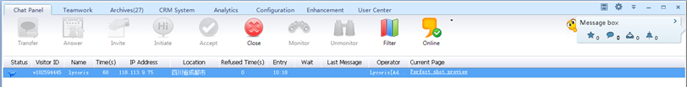
Tips: Display different functions according to the permission of your admin.
 Invite visitor: Click this button, then you can send chat request to the selected visitor in which side the chat request icon will pop up. After the visitor accepts your request, you can talk with him or her.
Initiate Chat: Click this button, the chat window of the selected visitor will directly pop up and won’t affect visitor’s browsing. ( Initiate chat window can be popped up anytime and won’t be shielded)
Accept Chat: Click this button, then you can accept the chat request sent by the selected visitor and start chat with visitor
End Chat: Click this button, then you can end the chat with the selected visitor.
Monitor Operator: All the chat activities of the corresponding operators will be monitored (including chats between operators and visitors, and chats between operators).
Cancel Monitoring: Click this button, then you can cancel all the monitored chat activities of the corresponding customer service operators.
Filter Queue: Click this button, you can choose to view specific visitor. It is especially useful when there are lots of visitors. After filtering out the off-line visitors and the irrelevant ones, you can reduce the visiting number in the queue and quickly find the visitors you are interested in.

2.2 Visitor List
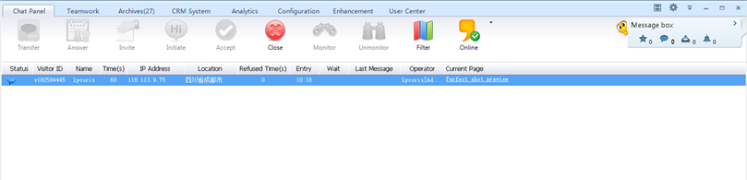
It has recorded in detail each visitor’s status, ID, name, keywords, search engine, visiting times, IP address, location, login time, waiting time, last message time, logout time, the customer service operator who is receiving the visitor, the current website and the visitor language etc. You can have a detailed knowledge of the visitor’s information in this window.
Illustration for Visitor’s Status:
(browsing the web page) (Visitor send chat request to operator)
(talking with me) (Talking with other customer)
(Being monitored) (Chat transferring to me from other operator)
(Visitor is away) (Chat transferring to other operator)
(Send chat request to visitor) (under processing)
(Visitor sends dial back request) (Visitor sends message to operator)
(Chat switch-on between visitor and operator)

2.3 Chat Interface
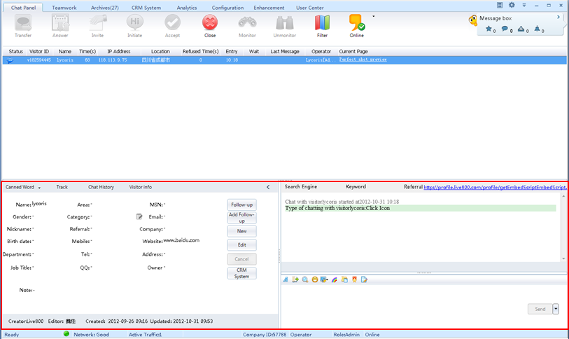

2.4 IM Chat
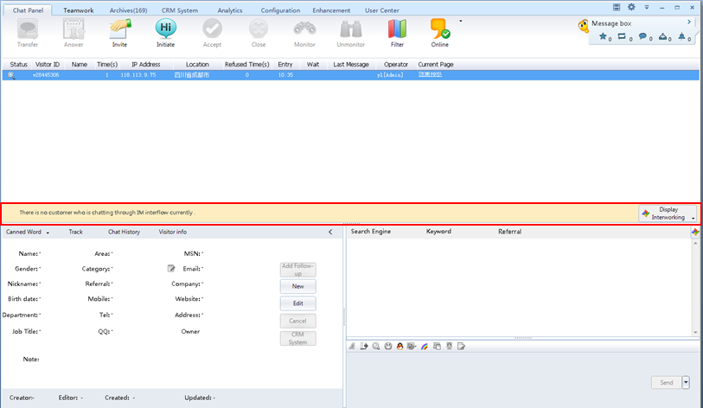
Display QQ、MSN IM chat list.
Tip: You need to enable the IM chat functions.

2.5 Operator Commonly Used Functions

You can click on the arrow to maximize or minimize extended function.

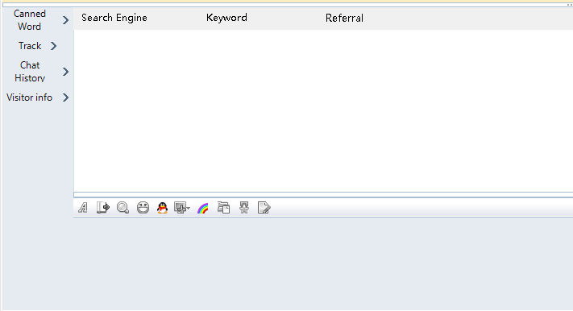
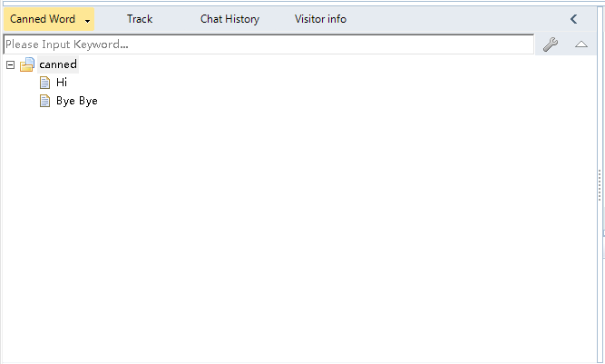
Track
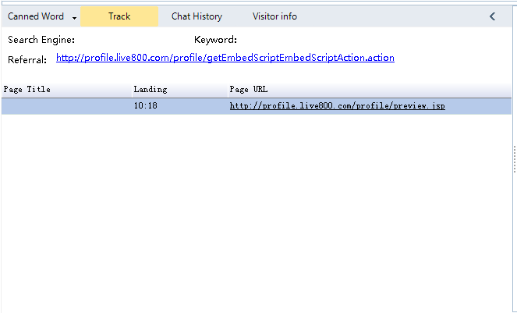
Chat History
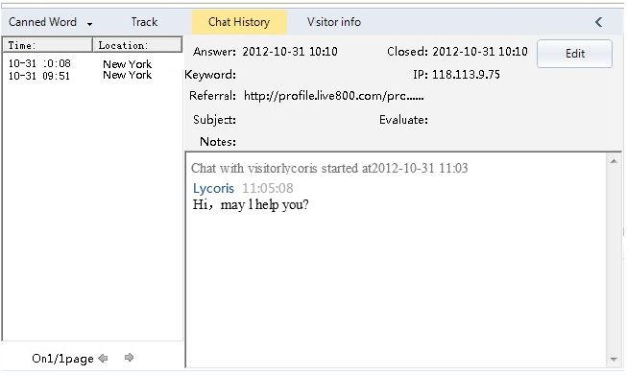
Visitor Info
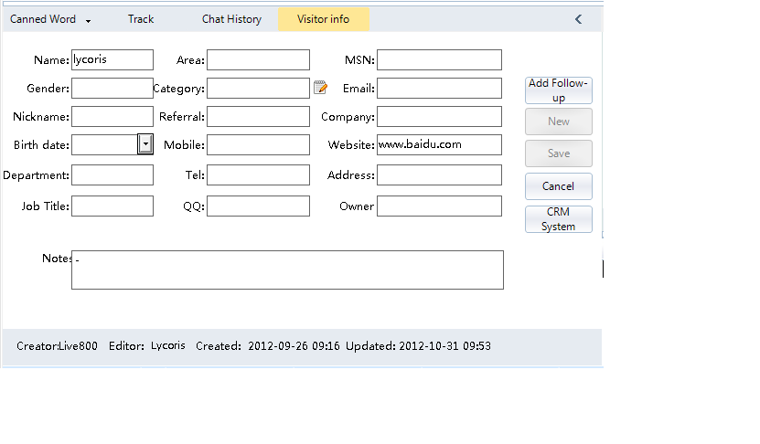

Three.Teamwork

3.1 Co-work
Operators can chat and share here.
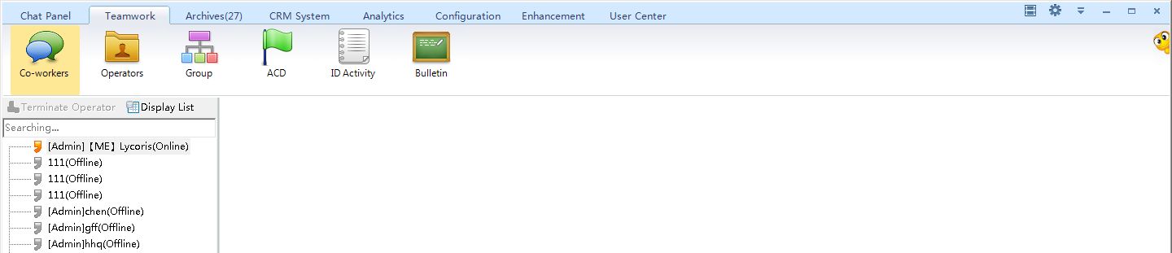

3.2 Operators
Admin can add, modify, disable and delete operators.
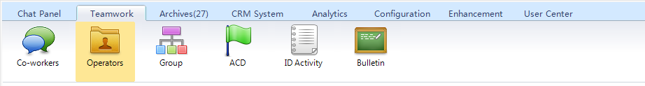

3.3 Group
Admin can add and modify groups according to different roles for different services. Visitors can click selected icon for direct chat.
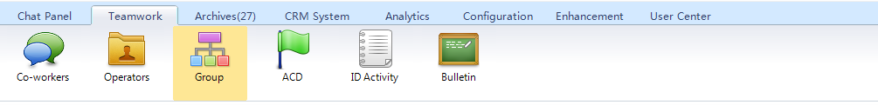

3.4 ACD
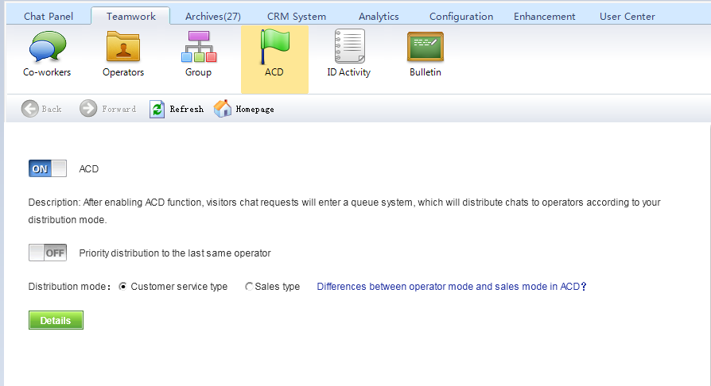
When Automatic Distribution is opened, the visitor’s chat request will go into Queue System where it will be distributed automatically to the customer service operator with the lightest workload, or to the customer service operator with whom the visitor talks last time if the Preference Distribution is opened. At the same time, the visitor can be told the request number before him or her in the queue. The customer service operators will be hinted if they continue to receive chat when they have the maximum visitors.

3.5 ID Activity
Here you can see the operator’s login time, exit time and way of logging, etc.
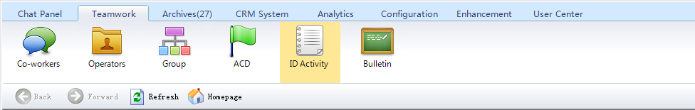

3.6 Bulletin
Admin can send notification to designated department or the specified operator in a certain time. You can also view history notification, fail the sent notice, modify the original notice and delete history notice.
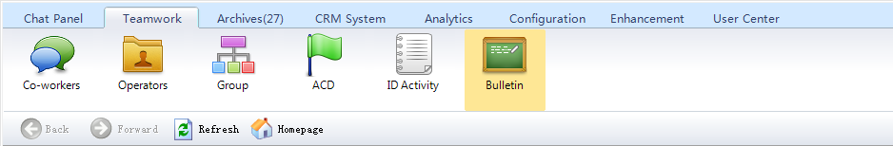

Four. Archives

4.1 Chat History
You can view chat history records through this function, and can preview and check chat records, make secondary evaluation in a particular time period; meanwhile, formal users can export or backup chat records, export support format is html and csv.
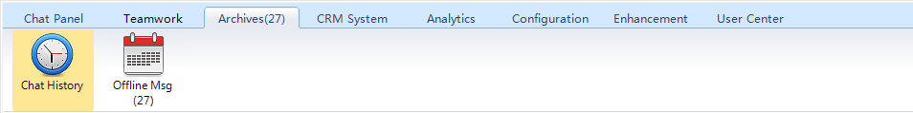

4.2 Offline Msg
You can view visitors’ messages. Message can show visitors’ name, IP, district, E-mail and message contents, operator can classify message and reply mail immediately through this page.
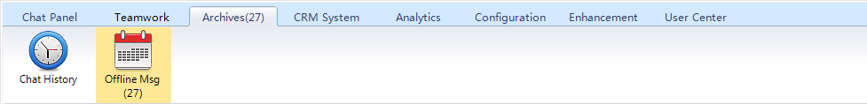

Five CRM System

5.1 Follow up
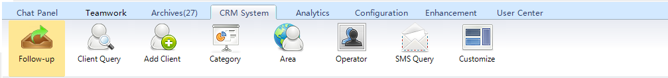
You can view and process the added follow-up records through a variety of conditions

5.2 Client Query
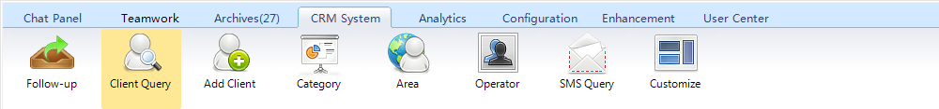
You can view and process the added clients’ records through a variety of conditions.

5.3 Add Client
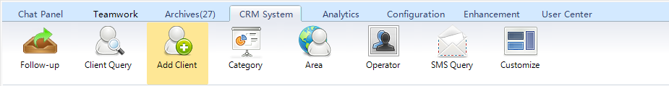
You and add clients here and modify clients info.

5.4 Category
You can analyze client info according to category.
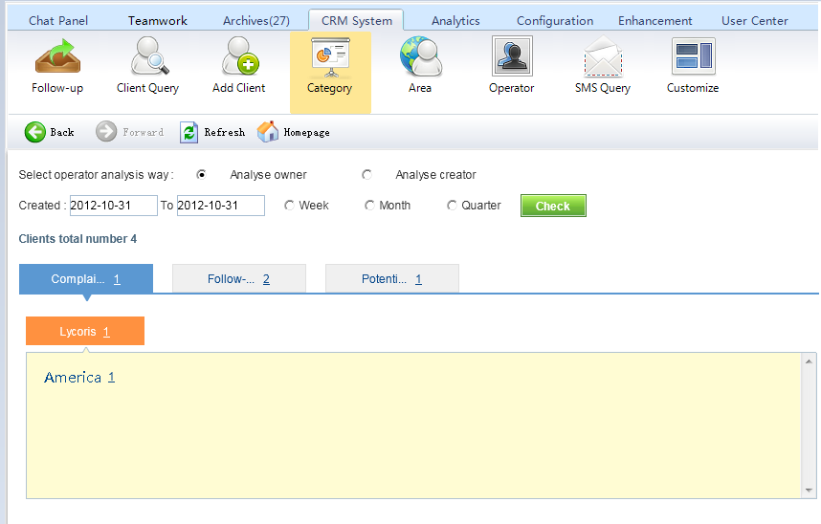

5.7 Area
You can analyze client info according to area.
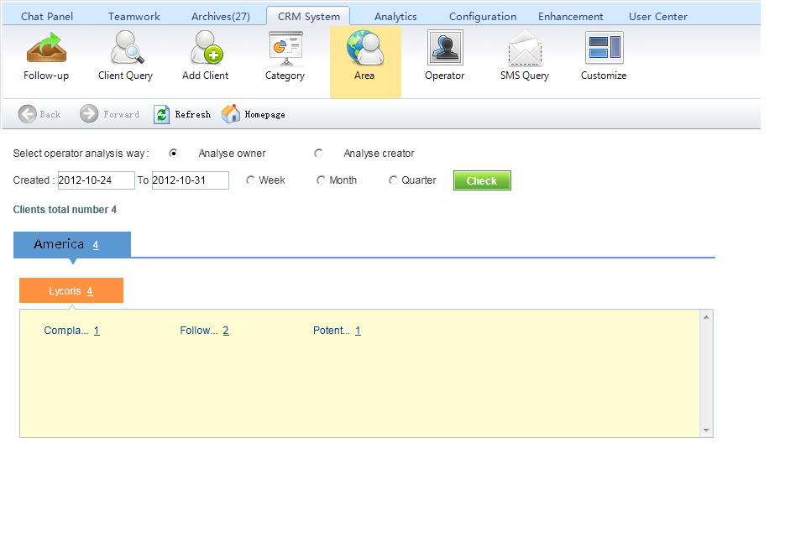

5.8operator analysis
You can analyze the number of clients created or owned by each operator.
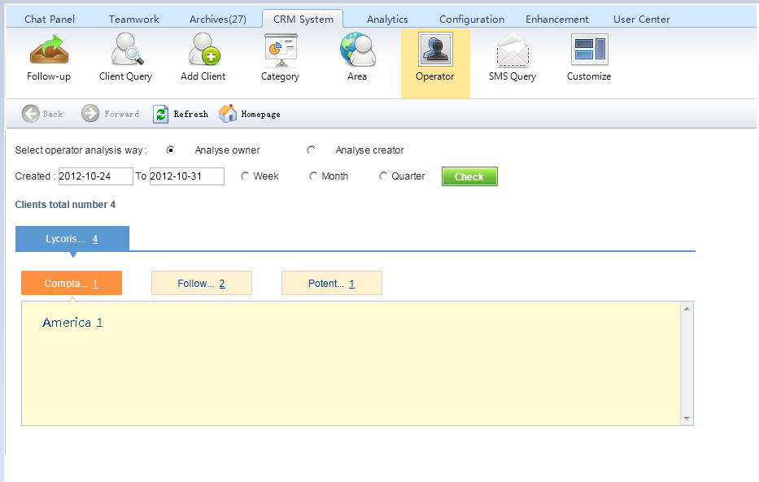

5.9 Msg Query
You can query your sent messages.
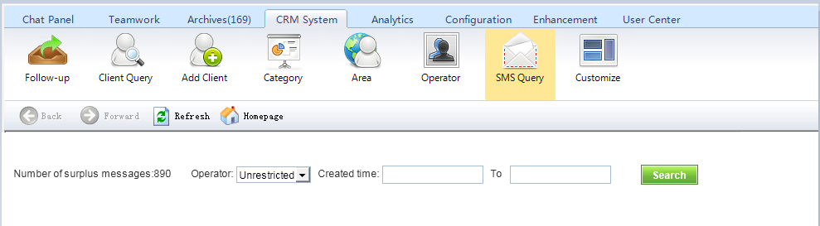

5.10 Customize
Client Info
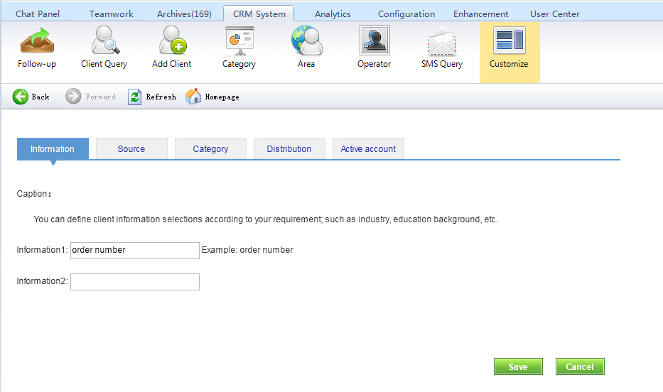
Visitor Source
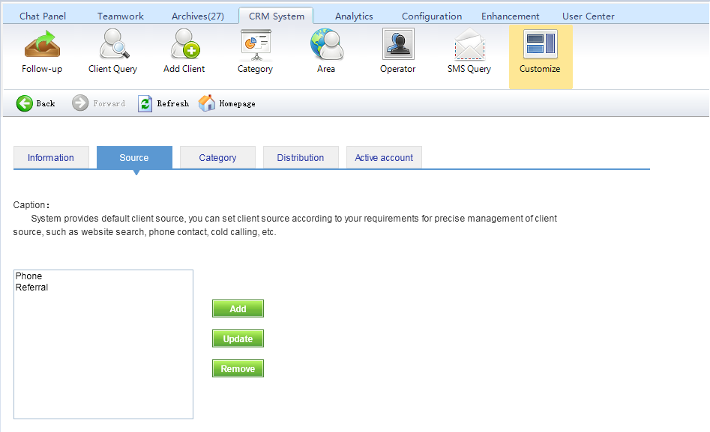
Client Category
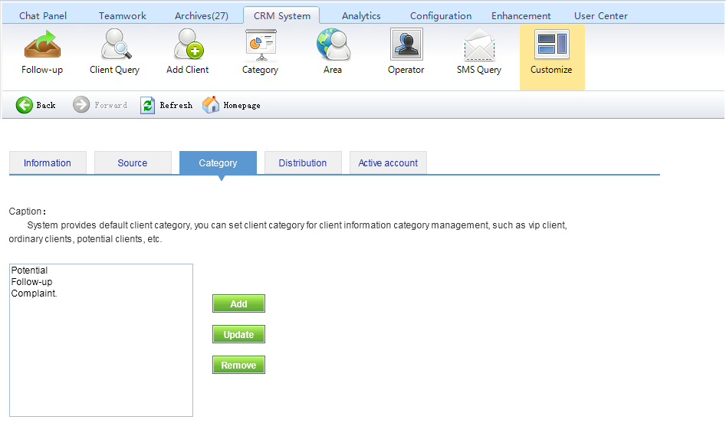
Efficient Client
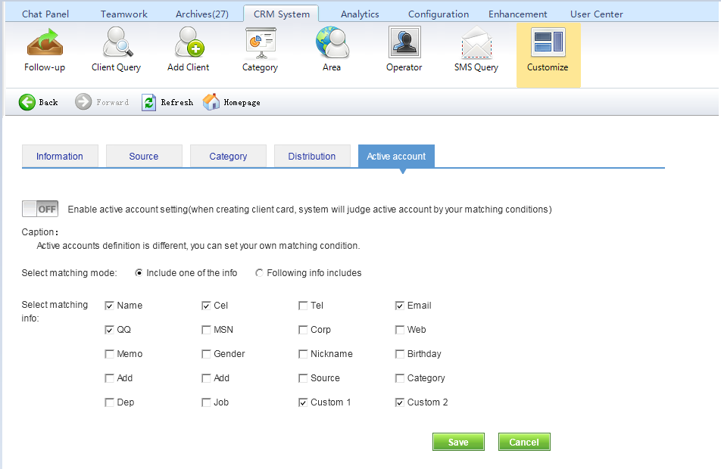

Six. Analytics
Live800 provides powerful data statistics and analysis function, offering help of business decision, such as: visitors’ region, source, chat theme, operators’ chat quantity and so on.
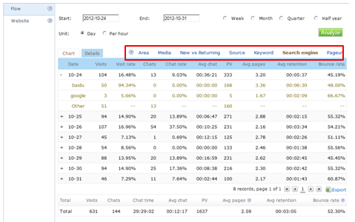

6.1 Web Overview
View your web overview, including visits, source, keywords and other important informations.
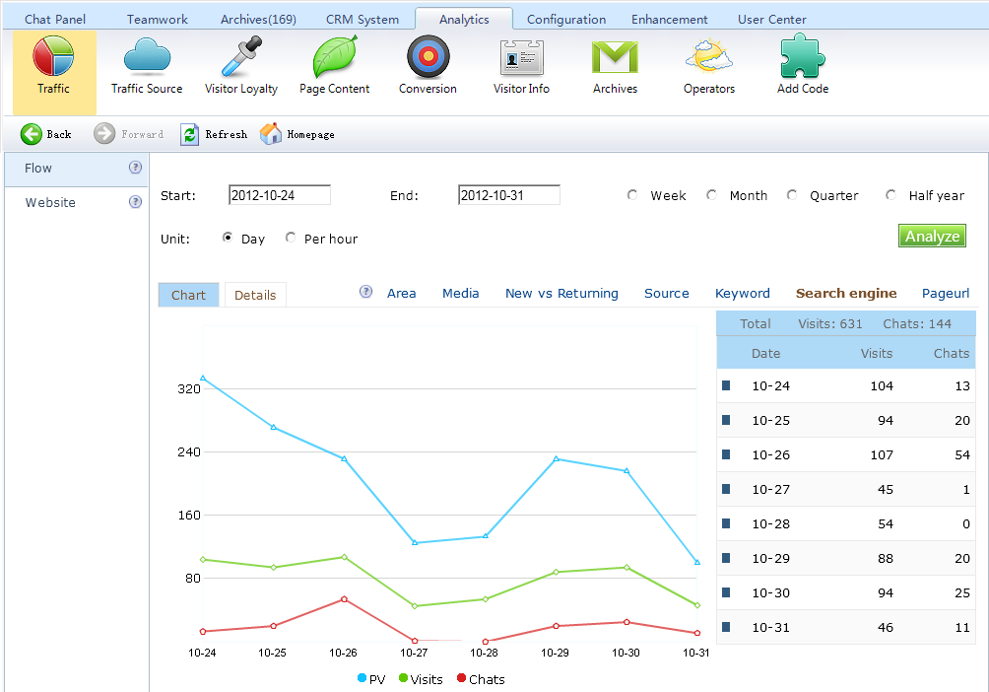

6.2 Traffic Source
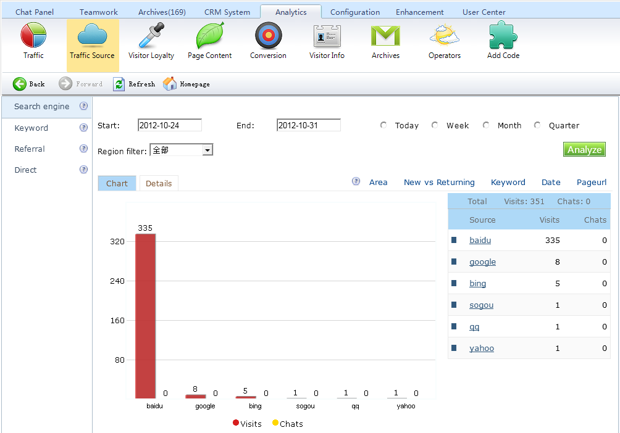

6.3 Visitor Loyalty
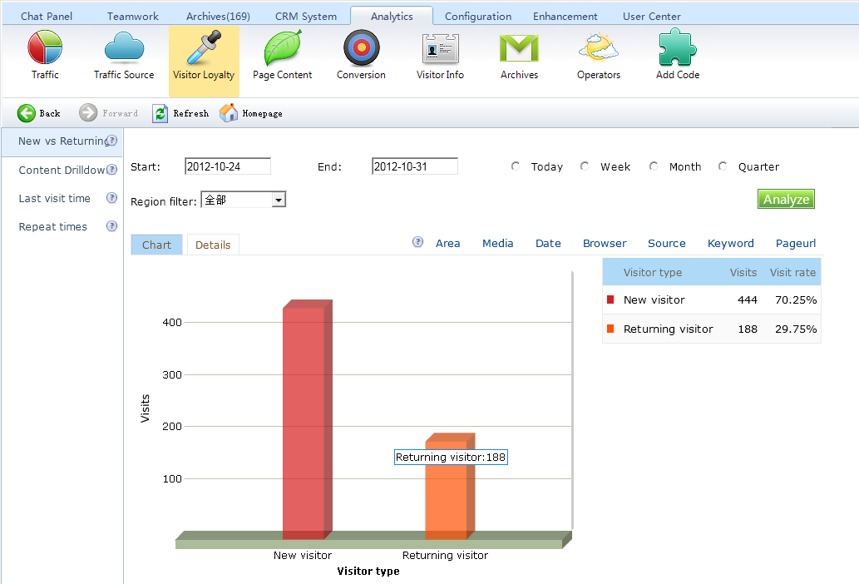

6.4 Page content
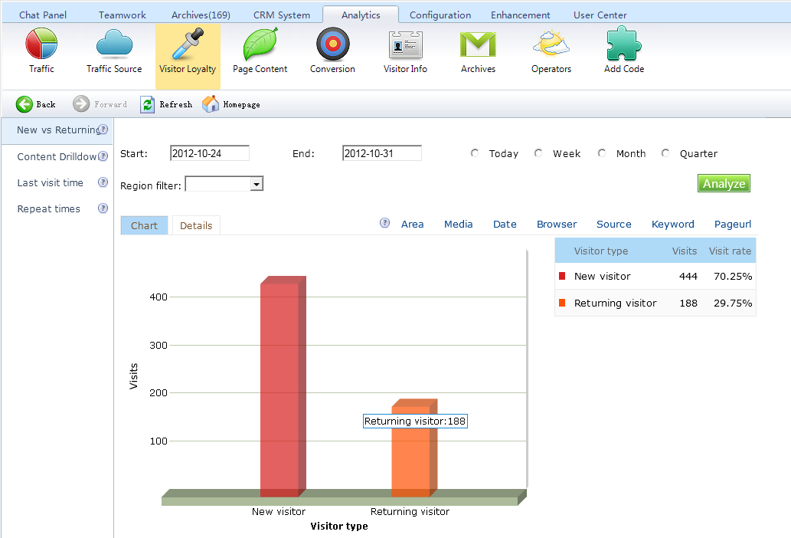
6.5 Goal Conversion
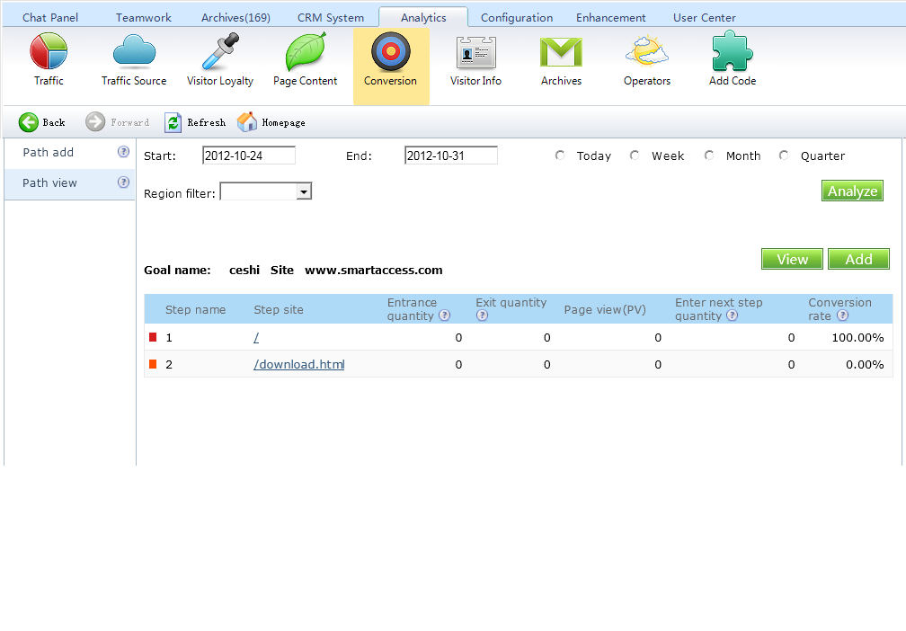

6.6 Visitor Info
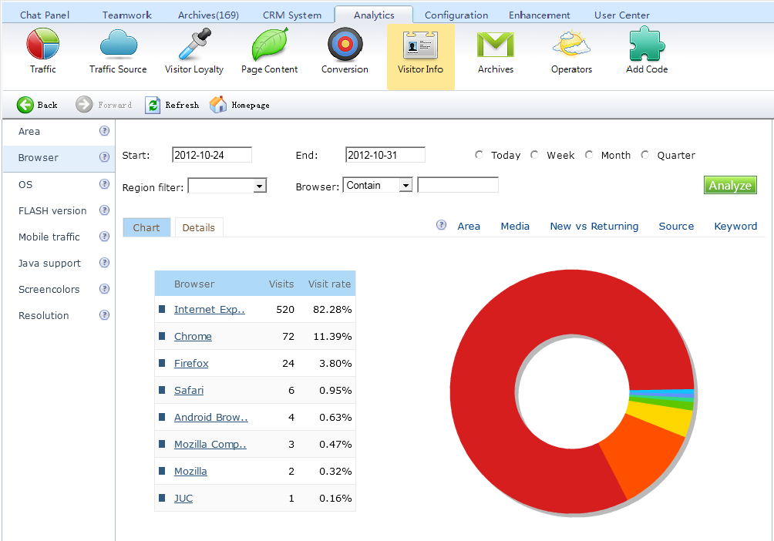

6.7 Archives
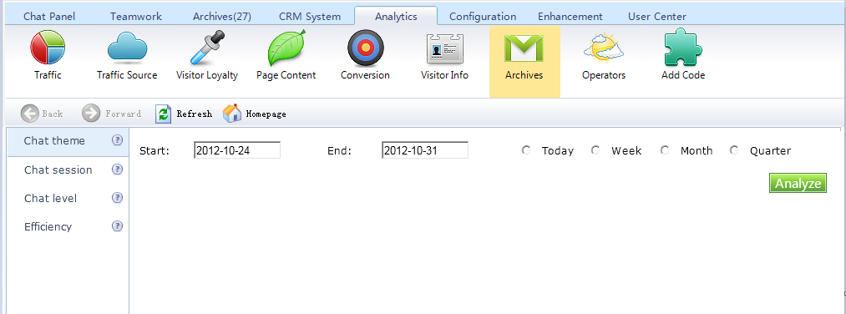

6.8 Operators
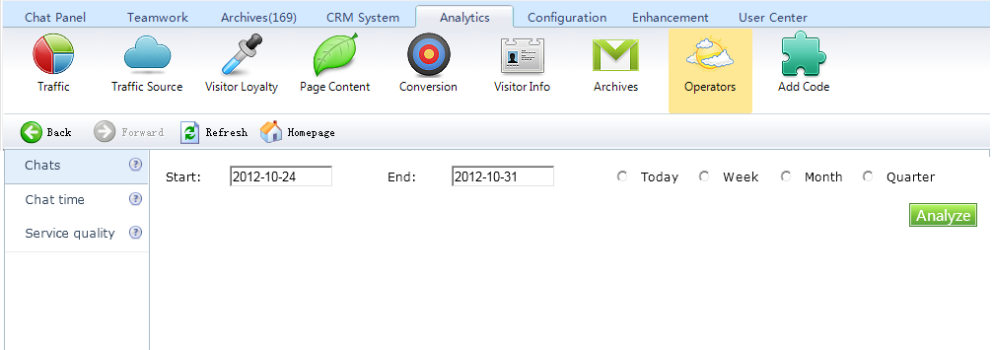

Seven. Configuration
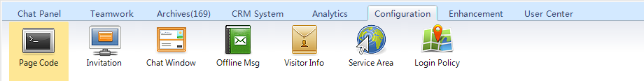

7.1 Page Code
Enter web page code, it will show you generated icon list. Select a certain icon, it will display the icon code, you can copy and embed in website source code, then it can begin to use.
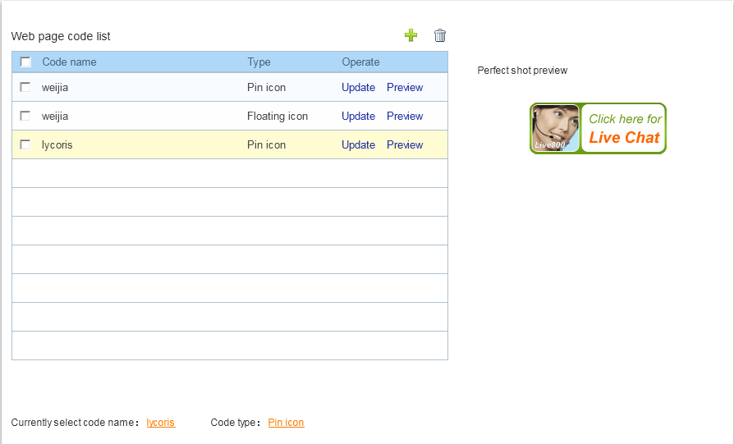

7.2 Invitation Window
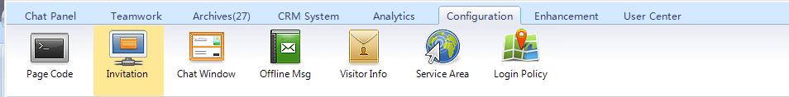
You can set your won style.

7.3 Chat Window
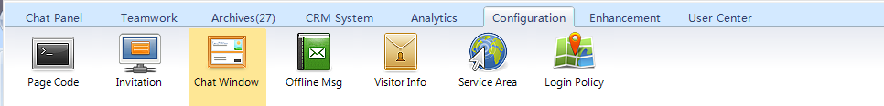
You can set ads, welcome words, end words, busy tips and so on.

7.4 Offline Msg
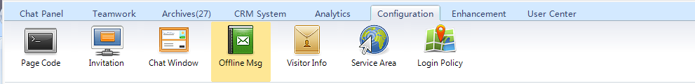
You can set offline message box as follows:
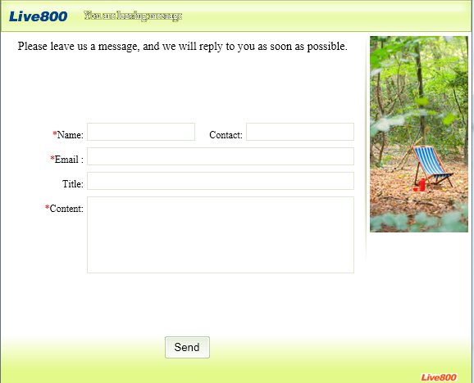

7.5 Visitor Info
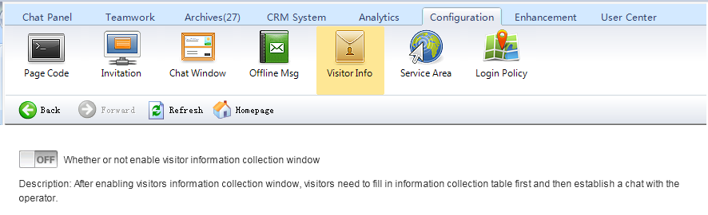
Once enabled visitors information collection window, visitors need to fill in information collection table to establish a chat with the operators.
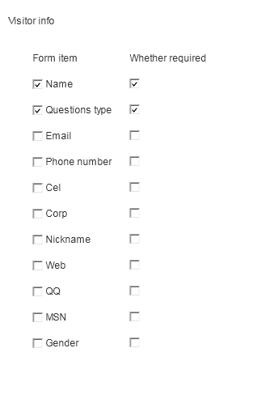
(Visitor client)
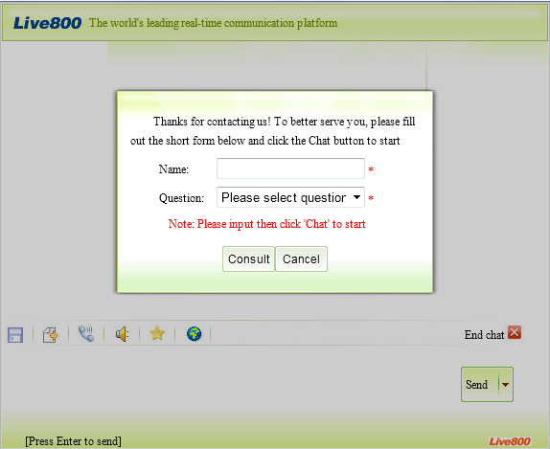

7.6 Service Area
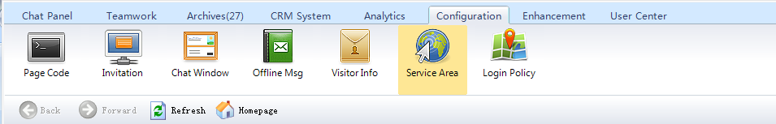
Find your potential areas and enable it.

7.7 Login IP
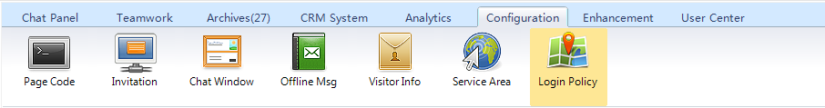
Login IP Setting: if you set login IP, outside of this IP will not be able to login, so as to protect your account security.

Eight. Enhancement
Tip：You have to enable it for use, please feel free to contact with Live800 online operators for more information.

8.1 Robot
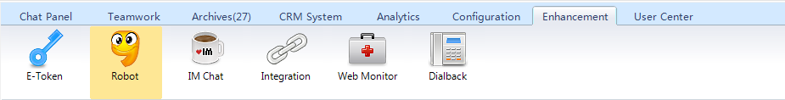
Robot function is a powerful unattended chat system launched by Live800 real-time communication platform. It has website, QQ, MSN robots.

8.2IM Chat
Live800 integrate with MSN, QQ for unified clients management and follow up.

8.3 Website Monitor
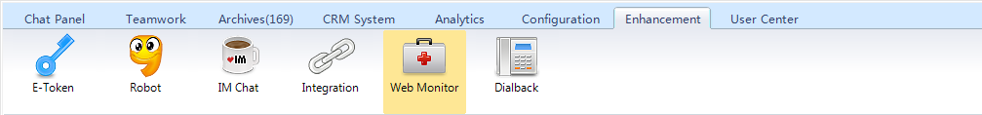
Monitor your website and ensure its normal work.

Nine. User Center

9.1 Billing
You can check your package use situations and enhancement services. 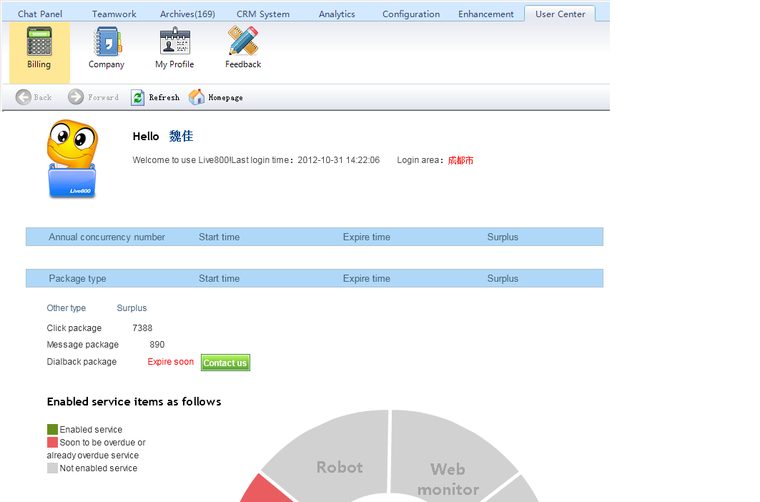

9.2 Company Info
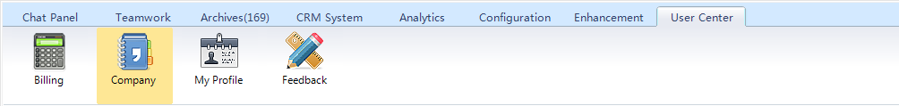

9.3 My Profile
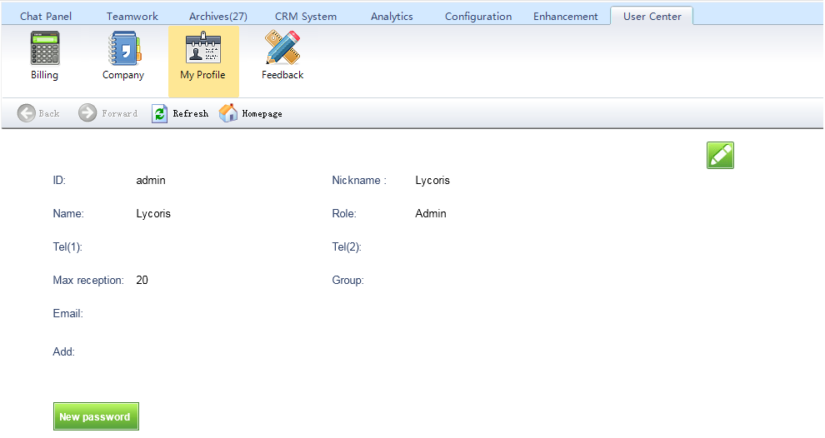

9.4 Feedback
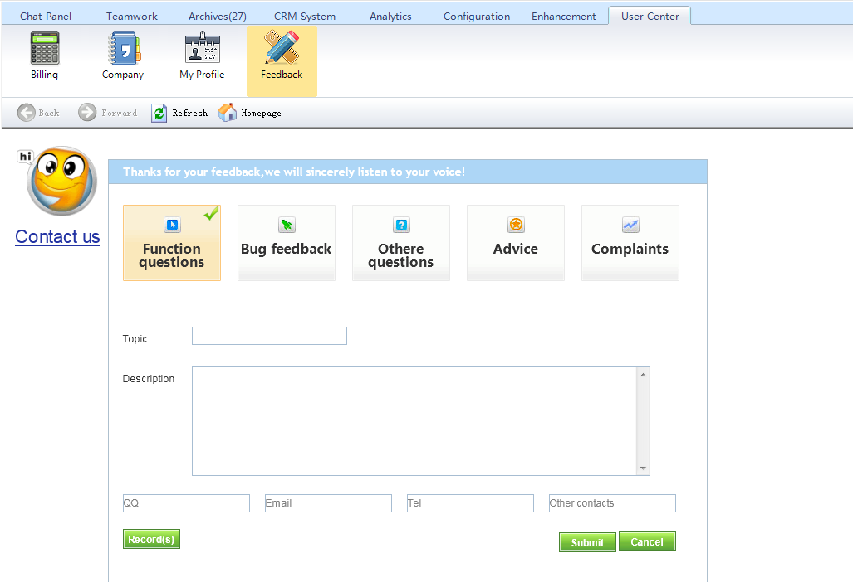

Ten. System Display and Set Instruction

10.1 Display
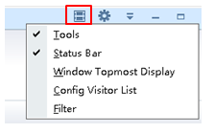
Toolbar
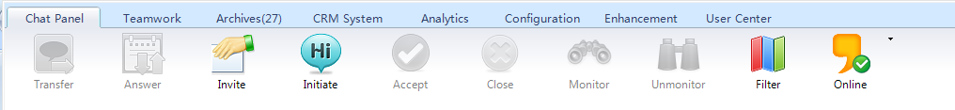
Status bar
Filter
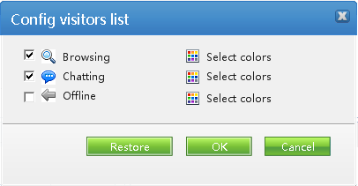

10.2 Setting
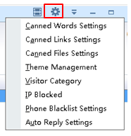
Canned words and canned links
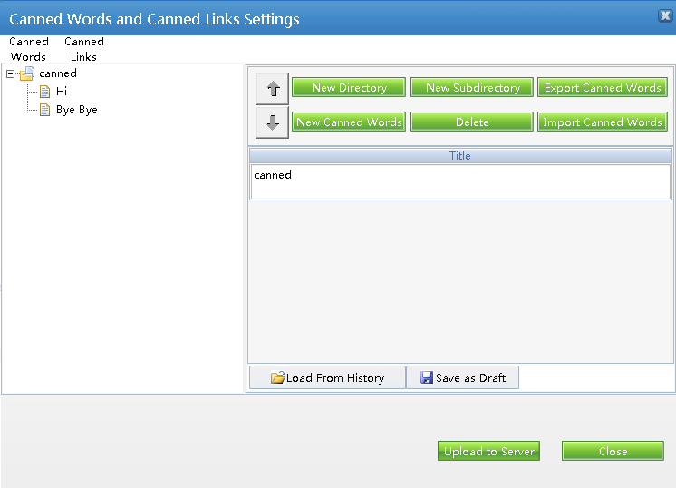

10.3 Main Menu
